The Territory’s Young Scientists Awards
Check out the Territory Young Scientist Competition Website
https://territoryyoungscientistcompetitionstant.weebly.com

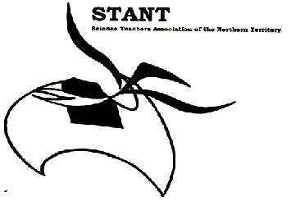
2019 COMPETITIONS
HANDBOOK

CONTENTS

Open Invitation & Overview of Competitions 2
Entry 5
Scientific Inquiry 6
Innovations and Inventions 8
Scientific Communication – Poster 10
Scientific Communication - Model 11
Scientific Communication – Scientific Writing 12
Scientific Communication – Video 13
Scientific Communication - Multimedia 14
Recycled Bugs 15
Be Crocwise 16
STEM in the NT – Refection 18
STEM in the NT – Investigation 19
Prizes 21
BHP Billiton Awards 22
BHP Billiton Teacher Awards 23
CREST Awards 24

Open Invitation and Overview of Competitions

Would you like to know whatever you do at school could win you great prizes in the 2019 Territory Young Scientists’ Awards organised by the Science Teachers’ Association of the Northern Territory (STANT).
You are invited and encouraged to enter one or more of the following categories:

- Scientific Inquiry - Students complete a practical investigation where variables are altered and an investigation of an effect is conducted. The topic can be independently chosen by the student or teacher directed in the selection of the topic or variables.
Entries in this category may be submitted for the BHP Billiton National Science Awards if they meet the National Criteria.

- Innovations and Inventions – Students build a physical device that demonstrates a scientific principle, solves a problem or provides a different approach to a problem. It should be a moving/working device and not static.

Entries in this category may be submitted for the BHP Billiton National Science Awards if they meet the National Criteria.

- Scientific Communication – Non Multimedia
  - Posters - Students create a visually stimulating poster on a scientist or conveys a scientific principle, concepts or issues
  - Models - Students make a labelled model that explain a scientific principle, issue or concept
  - Scientific Writing - Students using written word convey a scientific principle, idea, issue or concept. This can be done in various forms including a report, a storybook, a poem or an essay
- Scientific Communication – Multimedia –
  - Video - Students submit a video, Go Animate, clay animation etc, that communicates a scientific principle, issue or concept.
  - Web or computer based - Students using webpages, PowerPoint, electronic photo essays or another multimedia tool, communicates a scientific principle, issue or concept.

- Recycled Bugs – students create a bug using entirely recycled materials and explain its habitat and behaviour.

- Be Crocwise – students create an artefact (written piece, video, model or poster) that conveys the Be Crocwise message.

- STEM in the NT – My STEM Project
  - Reflection - Students submit a reflection on a STEM Inquiry Based Learning (IBL) project they have completed at school
  - Investigation – ​Student’s submit an investigation where variables are varied and an investigation into the effect is conducted with focus on the STEM design process.
For each of the above categories year level divisions apply, with individual and group awards in each division. (N.B.: Recycled Bugs only for primary levels) T-3 4-6 7-9 10-12

Six good reasons to enter the Territory Young Scientists Awards:

- Students can enter work they have done for school, no extra work required by the teacher is required.
- It’s a chance for students to further develop their scientific skills and pursue topics that interest them.
- There are several different age divisions, and lots of categories, so everyone has a chance to win prizes. In 2018, over $12,000 in prizes were given across the different divisions.
- It’s an opportunity for students to show their great work to other Territory students and the general public.
- Research investigations may be entered into the National BHP Billiton Science Awards. Students who make the semi-finals of this national competition receive prizes, finalists receive a trip interstate and have the opportunity to win a trip overseas.
- Participation provides opportunities to address achievement standards from the Australian Curriculum and SACE Board Curriculum Statements.
EACH ENTRY MUST BE ACCOMPANIED BY THE CORRECT ELECTRONIC ENTRY FORM
(https://www.cognitoforms.com/STANT2/_2019TerritoryYoungScientistCompetitionEntryForm)

The Fine Print:
- The competition coordinator is Veronica Ross, located at Northern Territory School of Distance Education. For any queries please contact:
Veronica Ross
C/ -Northern Territory School of Distance Education
Atkins Drive, The Gardens, NT, 0820
Ph: 89222217
veronica.ross@ntschools.net
- Entries can be submitted electronically at any time of the year, closing date is 27th September 2019 (Friday of the last week of Term 3).
- Please enter all entries electronically from your school for judging.
- Models and Recycle bugs will need to be photographed or videoed to be submitted electronically. If posters are on poster board, please also photograph to submit.
- No entries are to be submitted physically at Darwin Middle School as the school no longer has storage facilities as in previous years.
- Schools will be supplied with participation certificates for all competition entries.
- Prizes and winners certificates will be presented at a Ceremony to be held in Darwin in November 2018. All winners and their teachers will be invited to this ceremony. For those who cannot attend, prizes and certificates will be sent to the schools.
- As entries are submitted electronically there is no need to return entries. Certificates and prizes can be collected at the awards ceremony. Teacher can collect all participation certificates and place getter awards at the awards ceremony.

How do I get started?

There is no need to make extra time in class to introduce the Territory Young Scientists’ Awards. You can capitalize on the excellent opportunities arising in your regular classes. Successful entries in the past have begun with interest in such things as recycling and cane toads.

Once interest is aroused your role is that of a resource person to:

- Incorporate suitable activities as part of your teaching program – many of the suggestions in this booklet are cross curricula.

- Look at projects from previous years, check out http://www.scienceawards.org.au/

- Enrol and participate in CREST CREativity in Science and Technology https://www.csiro.au/en/Education/Programs/CREST/CREST

- Encourage students to carry out their own experiments and observations.

- Set a project, game or essay as part of your science program.

- Put some questions to the class to discuss how to structure an investigation.

- Set a suitable science topic as an essay in English classes.

- Get students to bring in materials from home for model building.

- Use computer time and a digital camera to record and present some science related event or process happening around the school

- Using Marker Spaces design innovations or models

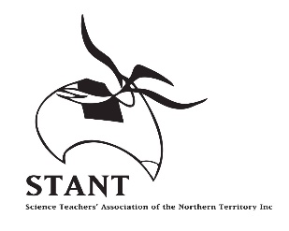
ENTRY SUBMISSION 2019

The Territory’s Young Scientist Competition

This year the Territory’s Young Science Competition has gone electronic.

ALL ENTRIES are to be submitted electronically through the Territory Young Scientist Competition website https://territoryyoungscientistcompetitionstant.weebly.com using the entry form platform Cognito Forms -https://www.cognitoforms.com/STANT2/_2019TerritoryYoungScientistCompetitionEntryForm

To enter:
- Complete the Entry information, Student details and School details located on the electronic entry form
- Enter the student’s entry using the Entry submission

IMPORTANT messages
- Word and PowerPoint – use the Word and PowerPoint upload section
- You Tube / Google doc / Dropbox / or any other online platform - use the Links to website section
For models, innovation and inventions, and recycle bugs, photographs or a video of the model also need to be submitted

For posters or scientific inquiry projects on poster paper, photographs of the poster or a scanning of the poster need to be submitted.

For any Inquiries please contact Veronica Ross
C/- Darwin Middle School
Atkins Drive, The Gardens NT 0820
veronica.ross@ntschools.net PH 89222217

If encountering any problems please contact me.

THE CLOSING DATE FOR ALL ENTRIES IS FRIDAY 28th SEPTEMBER 2018

Scientific Inquiry

An investigation is a piece of original experimental research. To enter this category, your basic investigation topic will be set by the teacher or be independently chosen by the student. Your teacher can set the variables or set the topic and you will identify and test the variables or be independently chosen by the student. Students may collaborate with scientists or other associations/people that may help guide them.

Entries will be judged on the following criteria:

- Select a question you would like answered. The question MAY relate to a scientific issue of importance to the community (e.g. pollution, brand comparison, electricity production, recycling etc).
- State a hypothesis you will test.
- Identify the risks involved - Risk Form located
- Design an experiment that will test your hypothesis.
- Do your experiment.
- Measure and carefully record the results of the experiment. This could include data, graphs, pictures, photos, sketches or a logbook.
- Write a discussion that looks at the patterns in the results. Discuss strengths and weaknesses of the experiment, and explain how you could improve your experiment if you did it again.
- Write a conclusion that briefly explains the answer to your original question.
- Make a list of any references you used in preparing or writing about your experiment.

All the information should then be presented in any appropriate form including a practical report, poster, photo essay, webpage or other method.

The following marking scheme will be used to judge entries. Where a section is not required for a particular experiment (e.g. experimental diagram or results graph) then students will not be disadvantaged.

Question | Background theory researched/explained clearly and concisely (10-12 especially)
 | Writes an aim in correct format
Hypothesis and Variables | Independent and Dependent variables correctly identified
 | Controlling variables correctly and clearly stated
 | Writes an hypothesis in correct format
Risk Assessment | Complete a risk assessment stating risks and precautions to consider
Experimental method | Equipment correctly listed, including quantities and concentrations
 | Appropriate equipment selected and used
 | Diagram (where appropriate) completed neatly and fully labelled
Results | Observations (where appropriate) completed in detail.
 | Results carefully measured and formatted
 | Tables and graphs carefully constructed with titles, units and headings correctly done
 | Photos and diagrams labelled and clear (where appropriate)
Discussion | Pattern of results described
 | Suggested reasons for results explained
 | Strengths and weaknesses described and effect on results explained
 | Improvements realistic and well described. Effect on results clear
Conclusion | Results summarised and related to aim/hypothesis
References | Correctly formatted list included where appropriate
Scientific Literacy | Correct format used
 | Correct use of scientific terms and units
 | Expression clear and concise
 | Good spelling and grammar
Innovations and Inventions (Engineering Category)

What is an invention? Inventions are original applications of technology which solve a problem. The scope for inventions is limited only by your imagination. You are asked to apply your knowledge of science to make a WORKING invention that has a practical application. Your invention may be a new device, method or process that has not existed before or you may choose to look at an existing device and invent a solution that works better.

Your Innovation or Invention may
- Solve a problem, for example:
  - How to build a bridge over a long distance
  - How to make a wind turbine spin more efficiently
- Provide a different approach to a problem, for example:
  - A new type of bicycle helmet
  - A new way to filter water for drinking

Entries will be judged on the following criteria:

- Identification of the issue, principle or problem that you are investigating.
- Working model to be built, then videoed in action, maximum 5 minute video which may also include explanations. Please note that the actual device will only comprise 25% of the final marks.
- Explain the scientific principles and theories around your model.
- Explain how you constructed your model, including materials used and how you made it work.
- If you are solving a problem or providing a different approach to a problem, explain how your model will solve the problem. Approach this from a social issues aspect.
- Include the risk assessment that you undertook before building your model.
- Make a list of any references you used in preparing or writing about your experiment.

PLEASE NOTE THAT ANY ENTRY USING HIGH VOLTAGE ELECTRICITY WILL NOT BE ACCEPTED. STUDENTS MAY USE POWER PACKS OR BATTERIES TO POWER THEIR DEVICES ONLY.

Your entry will need to include
- A written report outlining the principles investigated above
- A risk assessment
- A working model
- A short video demonstrating its use

The following marking scheme will be used to judge entries. Where a section is not required for a particular experiment (e.g. experimental diagram or results graph) then students will not be disadvantaged.

Issue | Issue clearly stated and explained in context to society.
Risk Assessment | Complete a risk assessment stating risks and precautions to consider
Model | Model construction is sound
 | Model works to demonstrate principle or problem solution
 | Video is clear and shows working model in action
Scientific theory | Relevant science is presented and explained
 | Principle, model or problem is clearly linked to the science
 | Reference to the model is made
Construction | Construction is sound
 | Appropriate materials are used
 | Safety is considered and explained in the Risk Assessment
IF SOLVING PROBLEM | Clear explanation of how problem is being approached
 | Clear explanation of how solution works
 | Clear explanation of the benefits of solution to society
References | Correctly formatted list included where appropriate
Scientific Literacy | Correct format used
 | Correct use of scientific terms and units
 | Expression clear and concise
 | Good spelling and grammar

Scientific Communication - Poster

Posters are a great way of conveying information and ideas. This category encourages students to present a scientific idea in a poster which is informative, visually stimulating and accurate.

The poster should include
- A clear heading
- Diagrams and pictures which are labelled and referenced
- Written in the students own words
- Displayed on poster paper
- Must contain a scientific idea, and can include Croc Wise information
- Must be easily read from 1 m away

The following marking scheme will be used to judge entries

Presentation | Poster has a clear and catchy heading
 | Presented in a manner which is clear and easily understood
 | Is appropriate for the audience
 | Original and entertaining
Content | Factually correct
 | Written in the students own words
 | Informative and explains information clearly and concisely
Scientific Literacy | Presentation clearly explains the idea
 | Scientific terms, units and ideas correctly used and explained
References | Correctly formatted list included where appropriate

Scientific Communication - Model

Models are a good way to represent scientific principles and concepts by giving a visual stimulus. Models can be scaled representations of an existing device or invention. It can include working parts or may be static. This category encourages students to produce a labelled model with a written explanation to support the model.

The model
- Can either be a working or static model
- Be original and show creativity – no kit projects allowed
- Must include labels and a title
- Must include a written report that explains the scientific principles or ideas involved
- Must represent a scientific idea, concept or representation, and can include Croc Wise information
- Be well constructed
- Is safe to operate and complies with safety standards

The following marking scheme will be used to judge entries

Presentation | Well constructed
 | Original and creative
 | Contains labels and model title
 | Appropriate for the audience
Content | Factually correct
 | Written in the students own words
 | Informative and explains information clearly and concisely
 | Complies with safety standards
Scientific Literacy | Presentation clearly explains the idea
 | Scientific terms, units and ideas correctly used and explained
References | Correctly formatted list included where appropriate

Scientific Communication - Scientific Writing

The ability to communicate scientific ideas and concepts to the public requires skill. Writing a piece that inspires, impresses and informs can change the world. This category encourages students who may become budding journalists and science writers the opportunity to share scientific ideas and concepts through written languages.

The piece of scientific writing can be in a number of different genres
Recount Information report Narrative Discussion
Procedure Persuasion/Exposition Response Description
Explanation

Your writing entries should
- Either be hand written of typed
- Include a reference list of all sources used
- Provide a text referencing for middle and senior entries
- May include diagrams or illustrations also referenced
- If quoting directly from a source, you must use quotations marks and referencing
- Interesting and informative

The following marking scheme will be used to judge entries

Resources/References | Details of resources used presented in a correctly formatted bibliography
 | In text referencing for senior and middle years students
Content | Content is factually correct
 | Information is explained clearly and concisely
Scientific Literacy | Presentation clearly communicates ideas
 | Scientific terms, units and ideas correctly used and explained
Presentation | Presentation clear and easy to understand
 | Appropriate for audience.
 | Original and entertaining

Scientific Communication – Video
Video is an exciting and interesting medium used to convey a scientific principle and idea. Good video presentations can inform, entertain and possibly change the views of the audience. The information conveyed is just as important as good video editing and video techniques. This category encourages students to present a scientific idea or teach scientific principles in a creative and interesting way.

Video presentations will include
- Scientific content
- Originality, creativity and clarity of thought
- Impact on the viewer
- Editing
- Original work
- Be self-contained and not rely on other pieces of work such as a poster, notes etc.
- MUST be submitted via DVD, USB or Drop Box
- Not exceed 5 minutes

The following marking scheme will be used to judge entries.

Resources/References | Details of resources used presented in a correctly formatted bibliography
Content | Content is factually correct
 | Produced in the students own words
 | Information is explained clearly and concisely
Scientific Literacy | Presentation clearly communicates ideas
 | Scientific terms, units and ideas correctly used and explained
Presentation | Presentation clear and easy to understand
 | Appropriate for audience.
 | Original and entertaining
 | Edited and easily understood
 | Contain credits including a bibliography and software used

Scientific Communication – Multimedia

With the changing world and improvements in technology, the way we as scientists can communicated ideas and concepts become varied. This category encourages students to present a scientific idea or teach scientific principles in a creative and interesting way. Any format is acceptable, as long as it is multimedia based and not a video.

Posters submitted on Word or in PDF form will be entered in the non-multimedia category.

Possible formats include:
Webpages PowerPoint presentation Electronic photo essay
Prezi

Multimedia Presentations
- Need to include more than one page
- Be interesting, informative and innovative
- Engage with the audience
- Must be referenced correctly
- Convey a scientific concept or principle

Resources/References | Details of resources used presented in a correctly formatted bibliography
Content | Content is factually correct
 | Written in the students own words
 | Information is explained clearly and concisely
Scientific Literacy | Presentation clearly communicates ideas
 | Scientific terms, units and ideas correctly used and explained
Presentation | Presentation clear and easy to understand
 | Appropriate for audience.
 | Original and entertaining

Recycled Bugs – (Primary Years only)

Students make a bug entirely of pre-used materials.

- Students may use glue, sticky tape or Velcro
- Bugs MAY NOT be painted
- Your bug must be accompanied by a description of exactly where it lives and how it is adapted to live in its environment.

Students should choose an environment for their bug and consider the adaptations it will need to live in that environment. For example:

- Space bugs – how does it breathe with no air, how does it feed, how does it travel?
- Desert bugs – how does it deal with heat, what does it feed on, where does it live?
- Wood bugs – what does it feed on, how does it avoid predators?
- House bugs – where does it live in your house, how does it avoid humans?

Students will be judged on the following marking scheme:

Bug construction | Bug uses recycled (pre-used) materials only
 | Bug is original and shows imagination
Explanation | Description of bug features given (e.g. how many legs, eyes etc)
 | Description of bug habitat (space, desert etc)
 | Description of how bug adapts to its habitat

Be Crocwise – (Primary Years Only)

Crocodiles are a critical organism in the Top End ecosystem. With their increase, the need to be crocwise is important. The NT government provides many resources to promote crocodile safety in and around our waters. Visit the Be Crocwise website for ideas and resources. https://nt.gov.au/leisure/parks-reserves/be-crocwise-learning-materials-and-talks

In this category students produce a piece of work that reinforces the Be Crocwise message. It can be;
- A written piece including a story, poem, newspaper article or research
- A poster
- Artwork
- Song
- Video or animation
- Webpage or multimedia presentation

The following marking scheme will used to judge entries

Content | Content is factually correct
 | Written in the students own words
 | Information is explained clearly and concisely
Scientific Literacy | Presentation clearly communicates ideas
 | Scientific terms, units and ideas correctly used and explained
Presentation | Presentation clear and easy to understand
 | Appropriate for audience.
 | Original and entertaining
 | Edited and easily understood.

STEM in the NT – Reflection
This category encourages reflection through STEM activities. In this category students are encouraged to submit a reflection on a STEM Inquiry Based Learning (IBL) project they have completed at their school, which may include photos or a record of each step of the process. The STEM project needs a real world focus with integration of learning areas.
As educators you need to design and implement a STEM Inquiry Based Learning (IBL) project as per your schools everyday teaching, learning and assessment cycle. The resource engineering design process is a series of steps that could be used to guide students as they solve problems. Educators could encourage students to follow the steps of the design process to strengthen their understanding of open-ended design and emphasize innovation, problem solving and practicality.
Students are encouraged to submit a REFLECTION on how developing the following attributes assisted them to be successful in their STEM project. As part of the project, and during each phase of the project ask students to complete a reflection based on the five guidelines listed below.

In my STEM project I was:

- Creative – I used my imagination and my original ideas
- Compare the ideas in the initial prototype or design with the final solution

- Innovative – I tried new ways of thinking, working and doing
- What did you do differently in this project?

- A problem solver – I focussed on finding solutions
- How did you overcome obstacles in the project
- Critically evaluate the problem solving strategies you used

- A critical thinker – I used reason and logic and relied on evidence to form opinions
  - What did you know?
  - What did you need to know?
  - How did you access the information?
  - What did you do with that information?

- Collaborative: I worked and consulted with others
  - Who did you seek knowledge or assistance from?
  - How did you work as a team member?

If you require any assistant regarding the STEM Project please contact

Caitlin Conway T-9 STEM Consultant
caitlin.conway@nt.gov.au or (08) 89011304

Entries may be submitted in the form of annotated photos of student work, recounts, diary entries, posters or multi modal formats demonstrating evidence of the students’ voice in the reflection. A suggested mode for students STEM Project reflections is as follows
- Word document
- PowerPoint
- Poster
- Video
- Scratch
- Website
- Any other multimedia presentation
A Critical Thinker ….

STEM in the NT – Investigation

This category encourages investigations through STEM activities. In this category students are encouraged to submit an investigation on a STEM Inquiry Based Learning (IBL) project they have completed at their school, which may include photos or a record of each step of the process. The STEM project needs a real world focus with integration of learning areas.
As teachers you need to design and implement a STEM Inquiry Based Learning (IBL) project as per your schools everyday teaching, learning and assessment cycle. The resource engineering design process is a series of steps that could be used to guide students as they solve problems. Teachers could encourage students to follow the steps of the design process to strengthen their understanding of open-ended design and emphasise creativity and practicality.
​
Entries will be judged on the following criteria:
1. Select a question you would like answered. The question MUST relate to a STEM activity.
2. Identify the risks involved - Risk form
3. Design a prototype or product and test it.
4. Measure and carefully record the results of the investigation. This could include data, graphs, pictures, photos, sketches or a logbook.
5. Write a discussion that discusses strengths and weaknesses of the prototype or product, and explain how you would improve your prototype or product if you did it again.
6. Write a conclusion that briefly explains the answer to your original question.
7. Make a list of any references you used in preparing or writing about your experiment.

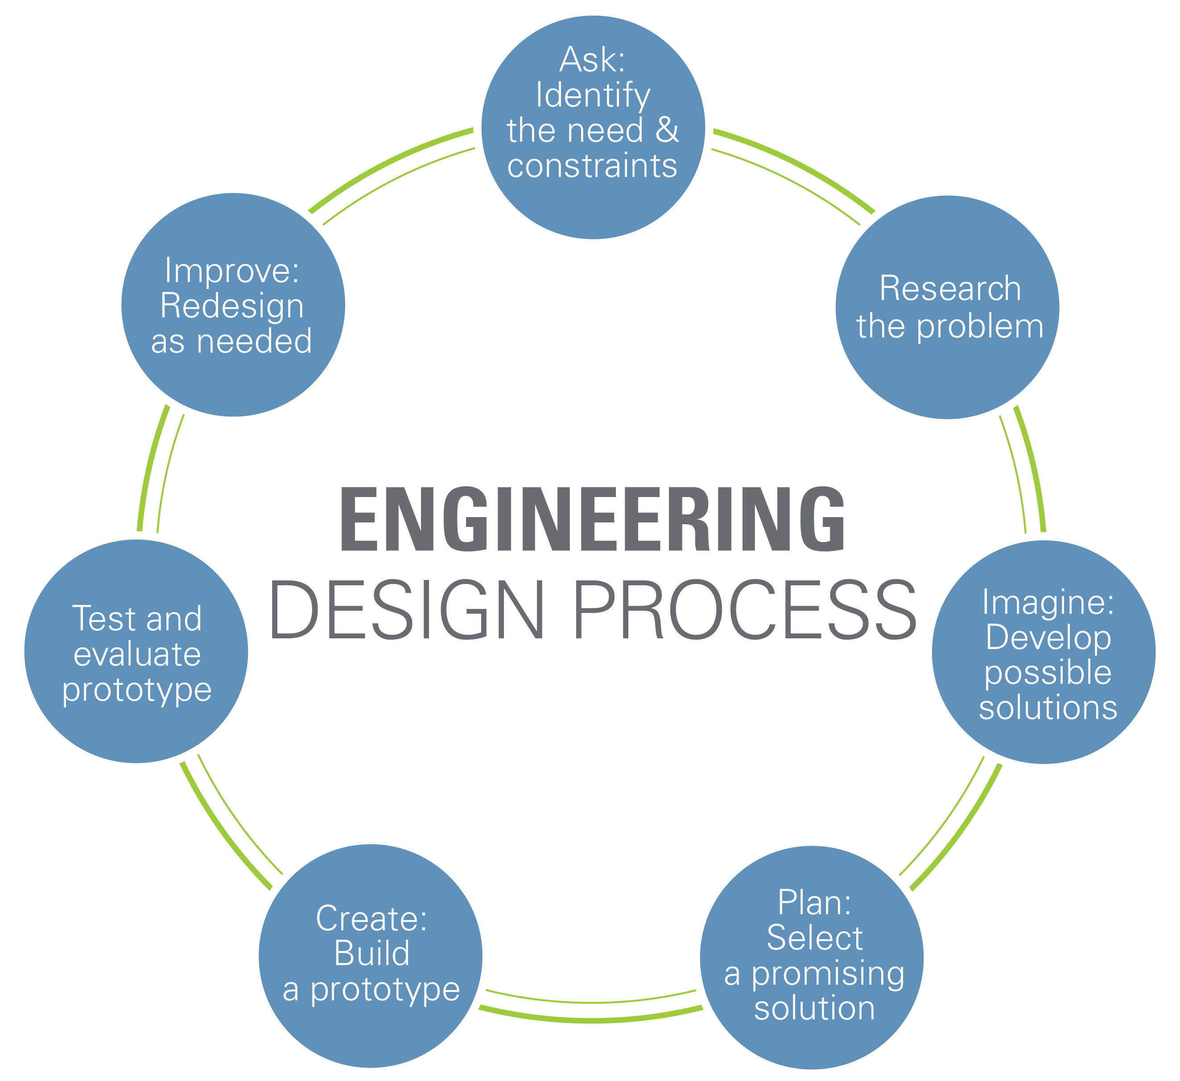

The following marking scheme will be used to judge entries. Where a section is not required for a particular experiment (e.g. experimental diagram or results graph) then students will not be disadvantaged.

Question | Background theory researched/explained clearly and concisely (10-12 especially)
 | Writes an aim in correct format
Risk Assessment | Complete a risk assessment stating risks and precautions to consider
Prototype Design | Evidence of product design - this may be plan and photos
 | Photographs or video of the product or prototype
 | Diagram (where appropriate) completed neatly and fully labelled
Results | Observations (where appropriate) completed in detail.
 | Results carefully measured and formatted
 | Tables and graphs carefully constructed with titles, units and headings correctly done
 | Photos and diagrams labelled and clear (where appropriate)
Discussion | Pattern of results described
 | Strengths and weaknesses of the prototype described
 | Improvements to the design
Conclusion | Results summarised and related to design of the prototype
References | Correctly formatted list included where appropriate
Scientific Literacy | Correct format used
 | Correct use of scientific terms and units
 | Expression clear and concise
 | Good spelling and grammar

Prizes

Individual or group winners of each category will receive

1st cash up to the value of $1500 each
2nd cash up to the value of $100 each
3rd cash up to the value of $100 each

All other entrants will receive participation awards.

Prize winners will be notified via their teacher in early November

The best practical investigations and innovation and invention devices will be forwarded to the BHP Billiton Science Awards and those finalists will be informed in Early December 2019.

Rowe Scientific School Awards

A school award will be presented to the winning school of each age category
- Early Childhood
- Primary
- Middle Years
- Senior Years

This will be awarded to the school that has produced the best quality entries and assessed on a point scale. The school with the highest score will be deemed the winner of the Rowe Scientific Award
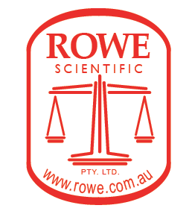
Point will be allocated as below
1st place will be awarded 3 points
2nd place will be awarded 2 points
3rd place will be awarded 1 point.

BHP Billiton Awards

The BHP Billiton Foundation Science and Engineering Awards are Australia’s most prestigious school science and engineering awards. The finalists are the best and brightest student researchers and innovators in the country. The BHP Billiton Foundation Science and Engineering Awards also recognise teachers who engage students in the study of open-ended investigations and work consistently within their school community and wider professional arenas to make an outstanding contribution to science education in Australia.
The BHP Billiton Foundation Science and Engineering Awards are a partnership between the BHP Billiton Foundation, CSIRO, the Australian Science Teachers Association, Science Teachers Association of the Northern Territory and all other state and territory Science Teacher Associations across Australia. Entry to the BHP Billiton Foundation Science and Engineering Awards is via nomination through the Territory Young Scientist competition.

Student Prizes

The top twenty-six finalists will be invited to an all-expenses paid, four-day educational science camp and the prestigious BHP Billiton Foundation Science and Engineering Awards ceremony to be held in Melbourne in February each year. Part of this camp includes the final judging round for the major prizes.

The top three projects from the Investigations category and top three projects from the Engineering category receive the following prizes:
- First prize A$4000
- Second Prize A$3000
- Third Prize A$1500

One finalist will be awarded the Innovator to Market prize. The Innovator to Market prize winner will receive an all-expenses paid experience including attendance at one of CSIRO’s ON programs and visit to CSIRO labs or centres.

The top twenty finalists will receive a A$250 prize.
Up to 100 semi-finalist entries will win A$100.

The finalist winners for the BHP Billiton Foundation Science and Engineering Awards will have the chance to participate in the Intel International Science and Engineering Fair (Intel ISEF) in the United State of America in May.

Up to eight winning primary entries will win A$250.
Up to 90 primary students will receive encouragement award prize packs.

Student Entry

Entry into the BHP Billiton Foundation Science and Engineering Awards is via nomination only, through the Territory Young Scientist Competition.

To be considered for nomination, please submit your project/s into the relevant categories:
- experiment, research or investigation category of Territory Young Scientist Competition
- the innovation and invention category of the Territory Young Scientist Competition

For nominated entries into the BHP Billiton Foundation Science and Engineering Awards, please ensure the following requirements are met, to be eligible for selection as a finalist:
- projects must include designing and carrying out an experimental investigation or engineering project
- the project has been nominated for entry through the Territory young Scientist Competition
- the PDF entry form and online entry form are both completed (contact your local STA for these forms)
- a written project report is uploaded with the online entry form (PDF preferred)
- project report includes acknowledgement of prior research/development and assistance from experts/industry professionals
- group projects include a maximum of three students
- students must be an Australia Citizen or permanent resident
- and for engineering entries only, a short video of the product in operation is uploaded with the online entry form (5 mins max)
Visit the BHP Billiton Science Awards website for more details www.scienceawards.org.au

BHP Billiton Teacher Awards

Teacher finalists will be invited to attend the BHP Billiton Foundation Science and Engineering Awards Teacher Best Practice Seminar and the prestigious BHP Billiton Foundation Science and Engineering Awards ceremony to be held in Melbourne in February each year. The winning teacher will also be invited to attend the Intel International Science and Engineering Fair (Intel ISEF) in the United State of America in May.
For further information or to download a teacher nomination form please go to http://www.scienceawards.org.au/teacher_awards/

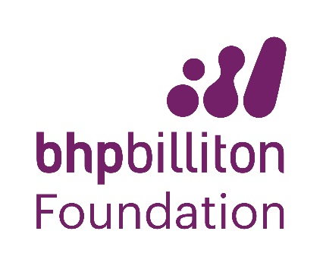
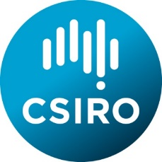

CREST Awards

CREST

CREativity in Science and Technology

- CREST is an awards program which encourages and supports primary and secondary school students to choose, organise and undertake their own practical science or technology project.

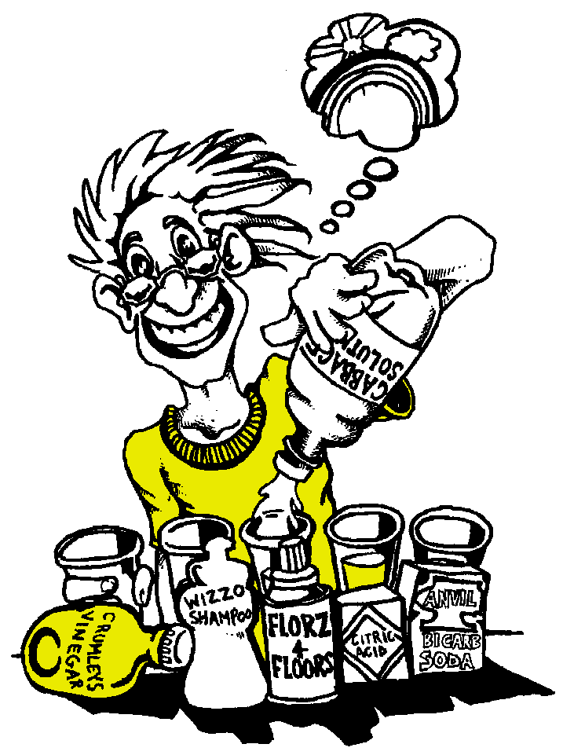
- Projects are offered at different levels, depending on the students’ age and experience.

- CREST helps students develop scientific and technological skills and processes.

- Students gaining CREST Awards must demonstrate that they have been Creative, they have Persevered and they have carried out research into a topic which has Applications in the everyday world.

- At higher levels links are made with industry or community workers and students gain a new understanding of the role of science and engineering in the community.

- CREST includes extensive written support material for both students and teachers as well as a comprehensive program of professional development for teachers.

- CREST Awards are nationally recognised and each student who completes a CREST project receives an attractive certificate and at most levels also a medallion.

- More than 6000 students achieve CREST Awards each year.

For more information contact:
National CREST Coordinator
Phone 1800 626 646
email crest@csiro.au

or visit https://www.csiro.au/en/Education/Programs/CREST

