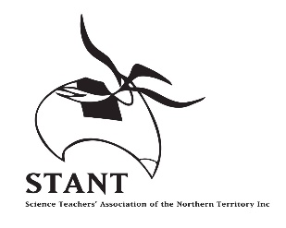
ENTRY FORM 2018

The Territory’s Young Scientist Competition

INDIVIDUAL | GROUP

AWARDS CATEGORY: (tick one)

PRACTICAL INVESTIGATION | SCIENTIFIC COMMUNICATIONS – NON MULTIMEDIA
TEACHER DIRECTED | POSTER
STUDENT DIRECTED | MODELS
 | SCIENTIFIC WRITING
INNOVATIONS AND INVENTIONS
 | SCIENTIFIC COMMUNICATION - MULTIMEDIA
RECYCLE BUGS | VIDEO
 | WEB OR COMPUTER BASED
BE CROCWISE
 | STEM IN THE NT

- Tick this box if you do not wish your practical investigation to be entered into the
National BHP Billiton Science Awards

ENTRANTS’ YEAR LEVEL or LEVELS (not age) : T-3 4-6 7-9 10-12

TITLE OR NAME OF ENTRY:
STUDENTS’ NAMES (please attach list if not enough space):
 | M / F / NS |  | M / F / NS
 | M / F / NS |  | M / F / NS
 | M / F / NS |  | M / F / NS
 | M / F / NS |  | M / F / NS
SCHOOL :
SCHOOL PHONE:
TEACHERS NAME
TEACHER'S EMAIL:
Send your entries to: Veronica Ross
C/- Darwin Middle School
Atkins Drive, The Gardens NT 0820
veronica.ross@ntschools.net

THE CLOSING DATE FOR ALL ENTRIES IS FRIDAY 28th SEPTEMBER 2018

